Matthew Garcia Nieves
5-2 Enhancement Three: Databases
10/16/2026
Artifact Description
The artifact I selected for the database category is my Grazioso Salvare project from CS 340: Client/Server Development. The project was originally created using Python and MongoDB and works with animal records from the Austin Animal Center. I created a Python CRUD module that connects to the MongoDB database and allows records to be created, read, updated, and deleted. The project also includes queries that filter animals based on the requirements for different types of rescue work, including water rescue, mountain or wilderness rescue, and disaster or individual tracking.
Why I Selected It and What I Improved
I selected this project because it was one of the projects where I worked directly with a database instead of only using data inside the program itself. The original project already demonstrated MongoDB queries and CRUD operations, but there were several areas I could improve to make the database portion more secure, reliable, and useful.
One improvement was changing how the program handles the MongoDB connection. Instead of storing the database username and password directly in the source code, the enhanced version reads them from environment variables. I also added a connection check using MongoDB's ping command so the program can verify that the server is available. Because I am currently running MongoDB locally without authentication, I also made the connection work without credentials when the environment variables are not provided. This allowed me to improve how credentials are handled without preventing the project from working in my current environment.
I also added a compound MongoDB index using the breed, sex_upon_outcome, and age_upon_outcome_in_weeks fields. I chose these fields because they are used together by the rescue-type queries in the project. The purpose of the index is to give MongoDB a more efficient way to search these fields as the collection grows. I tested the enhancement against the 10,000 animal records in my database and confirmed that the new rescue_filter_index was successfully created.
Another improvement was adding a MongoDB aggregation pipeline that creates a summary of the animal data by breed. The pipeline filters the records to dogs with valid breed information, groups them by breed, counts the number of animals in each group, calculates their average age in weeks, sorts the results by the number of candidates, and returns the top ten breeds. This gave the database functionality beyond returning individual records and showed how MongoDB can be used to summarize information that could be useful for making decisions.
Finally, I added validation before new animal records are inserted into the database. The program now checks that required fields such as the animal ID, animal type, breed, and sex upon outcome are present and contain valid text. It also rejects an age value if it is not numeric or is negative. I tested this using a valid record, a record missing its breed, and a record with an age of -5 weeks. The valid record was accepted while both invalid records were rejected. I then deleted the test record and confirmed that the database returned to its original 10,000 records.
Course Outcomes
For this enhancement, I believe I met the course outcomes I originally planned to address. The strongest connection is to Outcome Four, which focuses on using computing techniques, skills, and tools to develop solutions that provide value. The original project already used MongoDB for CRUD operations, but the enhancements allowed me to work with more database-specific features. I created a compound index for fields used by the rescue queries, added an aggregation pipeline for summarizing animal data, and improved validation before information is stored. These changes were intended to improve database performance and reliability while also making better use of MongoDB's capabilities.
The enhancement also supported Outcome Five because I changed how database credentials are handled. The original project stored the username and password directly in the source code. I removed those values and changed the program to read credentials from environment variables when authentication is being used. This reduces the risk of exposing database credentials if the source code is shared or uploaded to a repository. I also added error handling and a connection check so the program can respond when a database connection cannot be established instead of assuming the connection was successful.
There was also some progress toward Outcome Three through the decisions I made about database performance and processing. For example, I had to decide which fields should be included in the compound index based on how the existing rescue queries use the data. I also chose to perform the breed summary through MongoDB's aggregation pipeline instead of retrieving the entire collection and calculating the results in Python. This allowed more of the data processing to happen within the database. I do not have any major changes to my original outcome-coverage plan because the completed enhancement addressed the areas I originally intended.
Reflection on the Enhancement
One thing I learned from this enhancement was that improving a database project involves more than adding new features to what the user sees. Some of the most important changes I made are not immediately visible on the dashboard. The index, validation, aggregation pipeline, and credential changes happen behind the scenes, but they affect how efficiently, securely, and reliably the application works with its data. Working on this project helped me better understand why the way a database is designed and accessed matters just as much as displaying the information.
One challenge was getting the original project running again in my current environment. I had to rebuild the aac database from the original Austin Animal Center dataset and import 10,000 records into MongoDB. I also had to work through database connection and authentication issues before I could properly test the enhancements. Once the database was working, I tested each change separately instead of making all the changes at once. This made it easier to find problems and correct them without having to determine which of several changes caused an error.
Testing was also an important part of the enhancement. I confirmed that the compound index was created with the intended fields and that the aggregation pipeline returned breed counts and average ages. For validation, I tested a correctly formatted animal record, a record missing its breed, and a record with an age of -5 weeks. The valid record was inserted while both invalid records were rejected. I then removed the test record and confirmed the collection returned to 10,000 records. Finally, I retested the original rescue queries and received 17 water rescue results, 5 mountain or wilderness rescue results, and 4 disaster or individual tracking results. This helped confirm that the original functionality continued to work after the database enhancements.
After reviewing my instructor's feedback, I realized that confirming an index was created is not the same as measuring how much it improves performance. I verified that the compound index contained the intended fields, but I did not compare query execution statistics before and after creating it. In a future version, I could use MongoDB's explain() feature to compare execution times and the number of documents examined. This would give me a better idea of how much the index actually helps.
Another area I could test further is database authentication. I changed the program to read credentials from environment variables instead of storing them in the source code, but my current local MongoDB setup does not require authentication. Because of that, I have not fully tested the credential-handling changes against a database that requires a username and password. Setting up an authenticated database would allow me to verify that part of the enhancement more completely.
Testing Evidence
- Aggregation Enhancement Test –

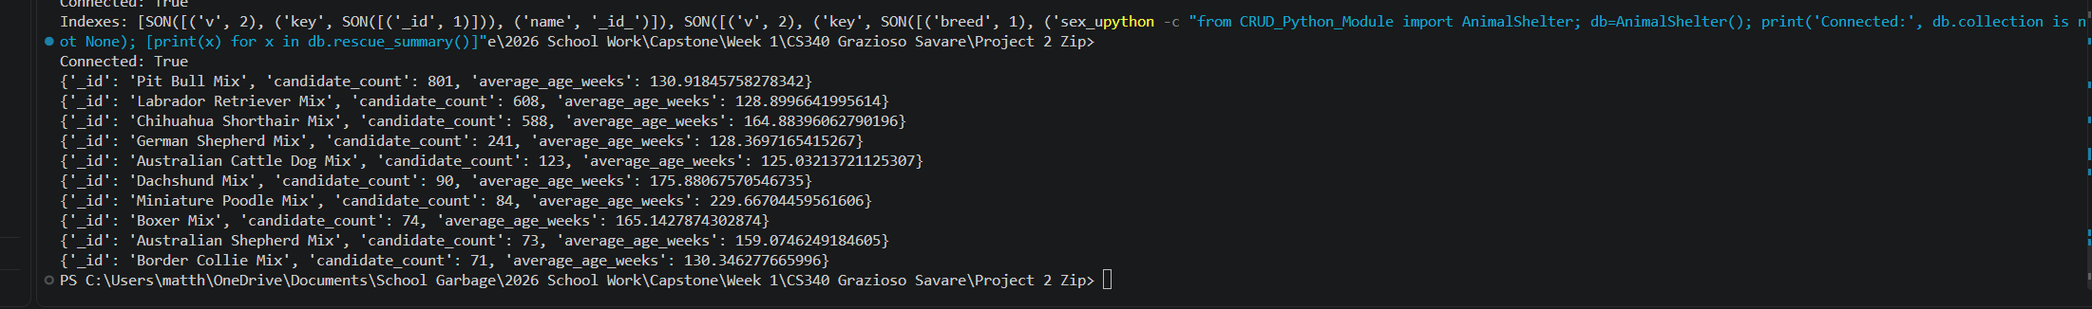

Figure 1. Aggregation Enhancement Test: The MongoDB aggregation pipeline successfully grouped animal records by breed and returned the candidate count and average age in weeks for the top ten breeds.

- Database Connection and Index Test -

Figure 2. Database Connection and Index Test: The enhanced program successfully connected to MongoDB and confirmed that the compound rescue_filter_index was created using the breed, sex, and age fields.

- Data Validation Test –

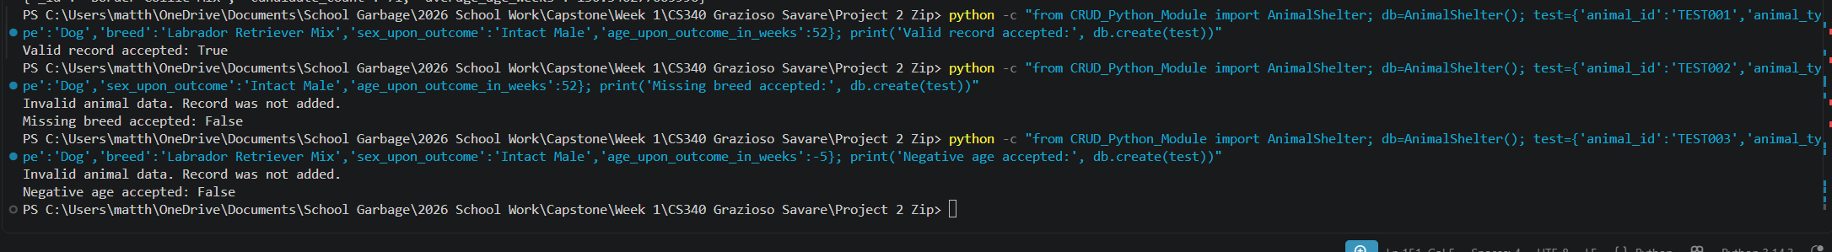

Figure 3. Data Validation Test: The enhanced validation accepted a correctly formatted animal record while rejecting a record with a missing breed and another with a negative age.

- Delete Regression Test –

Figure 4. Delete Regression Test: The valid test record was successfully deleted after validation testing, returning the MongoDB collection to its original 10,000 records.

- Rescue Filter Regression Test –

Figure 5. Rescue Filter Regression Test: The original rescue filters continued to work after the enhancements, returning 17 water rescue, 5 mountain or wilderness rescue, and 4 disaster or tracking candidates.

